AI Powered Personalised Study Planning and Learning Recommendation System

By

Kene Christopher Obiekwe
22120613021

Computer and Information Sciences Department
School of Science and Technology
Pan-Atlantic University

July, 2026

AI Powered Personalised Study Planning and Learning Recommendation System

By

Kene Christopher Obiekwe
22120613021

A project submitted to the School of Science and Technology, Pan-Atlantic University
in partial fulfillment of the requirements for the award of degree of Bachelor of Science (Computer Science) of Pan-Atlantic University.

July, 2026

Abstract
[The abstract should be one paragraph of between 150 and 250 words. It is not indented. Section titles, such as the word Abstract above, are not considered headings so they don’t use bold heading format. Instead, use the Section Title style. This style automatically starts your section on a new page, so you don’t have to add page breaks. Note that all of the styles for this template are available on the Home tab of the ribbon, in the Styles gallery.]
Keywords: [Click here to add keywords.]

ACKNOWLEDGEMENTS

Dedication

STUDENT'S DECLARATION
I have read and understood the School of Science and Technology Policy on plagiarism. I declare that this project is my own work and that all sources are fully referenced. I also declare that I have not submitted this work for any other purpose.

____Kene Christopher Obiekwe___
22120613021

Date: ____21/01/2026____

CERTIFICATION
I certify that this work was carried out by … with matriculation number …, in the School of Science and Technology, Pan-Atlantic University, under my supervision.

________________________________
Supervisor: Dr or Prof …
School of Science and Technology
Pan-Atlantic University
Lagos, Nigeria

Date: ______________

Table of contents
1 Chapter One: Introduction
1.1 Background to the Study 1
1.2 Motivation 3
1.3 Research Problem 4
1.4 Aim and Objectives of Study 5
1.5 Methodology 5
1.6 Significance of Study 6
1.7 Scope of Study 6
1.8 Limitations of Study 6
1.9 Definition of Terms 7
2 Chapter Two: Literature Review
2.1 Conceptual Framework 8
2.1.1 Self-Regulated Learning in Higher Education 8
2.1.2 Study Planning and Time Management in Learning 9
2.1.3 Learning Analytics in Educational Systems 10
2.1.4 Artificial Intelligence in Education 12
2.1.5 Conceptual Relationship Between SRL, Learning Analytics, and AI 14
2.1.6 Mobile-Based Learning Support and Study Behaviour Regulation 16
2.2 Related Works 16
2.2.1 AI-Based Tutoring and Intelligent Learning Systems 17
2.2.1.1 Carnegie Learning Cognitive Tutor 18
2.2.2 Learning Analytics-Driven Study Support Systems 19
2.2.2.1 OU Analyse (Open University Learning Analytics System) 20
2.2.3 Adaptive and Personalised Learning Systems 20
2.2.3.1 Knewton Adaptive Learning Platform 21
2.3 Knowledge Gap 22
2.3.1 Limitations of Existing Self-Regulated Learning Support Approaches 22
2.3.2 Gaps in Learning Analytics and AI-Based Educational Systems 22
2.3.3 Contextual Gaps in Existing Studies (Undergraduate/Nigerian Context) 23
2.3.4 Proposed Solution 24
2.4 Summary of Literature Review 24
3 Chapter Three: Systems Analysis, Design and Production
3.1 Analysis of Existing 26
3.1.1 Case Studies 26
3.1.2 Weakness in Existing Systems 28
3.1.3 Proposal of New System 30
3.2 System Design 30
3.2.1 Overview of UML as the Design Tool 30
3.2.2 Use Case Diagram 31
3.2.3 Class Diagram 32
3.2.4 Sequence Diagram 33
3.2.5 Activity Diagram 34
3.3 Technology Stack 35
3.3.1 Overview of Selected Technologies 36
3.3.2 Frontend Technologies 36
3.3.3 Backend Technologies 37
3.3.4 Database and Additional Tools 37
3.4 AI Methodology and Model Development Process 38
3.4.1 AI Objectives and Prediction Tasks 38
3.4.2 Data Collection Strategy 39
3.4.3 Dataset Construction and Target Definition 39
3.4.4 Data Preprocessing and Feature Engineering 39
3.4.5 Model Selection and Training Procedure 40
3.4.6 Model Testing and Evaluation Metrics 40
3.4.7 Deployment, Monitoring and Retraining 40
3.4.8 Ethical and Reliability Considerations 41
References 42

List of Tables

List of Figures

Figure 3.1: MyStudyLife Snapshot 27
Figure 3.2: Snapshot of Brightspace Pulse app 27
Figure 3.3: Carnegie Learning Snapshot 28
Figure 3.4: Use Case Diagram of the system 32
Figure 3.5: Class Diagram of the system 33
Figure 3.6: Sequence Diagram of the system 34
Figure 3.7a: Activity Diagram for Personalised Study Planning Workflow 35
Figure 3.7b: Activity Diagram for Study Monitoring & Optimisation Workflow 35

Chapter One: Introduction

Background to the Study
To be a successful higher education student, it is essential to plan study sessions and manage time properly to be productive. Higher learning students must possess a high degree of autonomy in order to meet their academic requirements. The independent structuring of learning patterns, the possibility to combine several courses and subjects and the maintenance of the regular studying habits are some of these requirements. The studies indicate that planning and controlling of studying and learning activities are the tasks that many students cannot undertake on their own and as a result, use their study time ineptly, experience academic stress, and perform poorly in general (Zimmerman, 2002; Broadbent, 2017).

The idea of self-regulated learning enables a better understanding of how students manage and plan their studies. Self-regulated learners readily organize learning tasks, establish goals, monitor progress and proactively amend learning strategies based on feedback (Zimmerman, 2002). Findings from research in higher education point towards the evidence that students who make use of self-regulation and time management approaches academically outperform others who employ unstructured study habits (Broadbent, 2017; Schraw, Crippen, & Hartley, 2006). Many students across higher education still rely on unregulated study patterns or casual decision-making processes that are difficult to maintain and lead to poor results despite the evidence that self-regulation in learning is effective.

Digital technology advancements have made it easy to assist the study patterns of students through adaptive and data-driven systems. The use of learning analytics and artificial intelligence for the analysis of study behaviours, feedback provision and personalized learning support in higher education is rapidly increasing (Viberg et al., 2018; Ifenthaler & Yau, 2020). These data-driven advancements crucially inform learners on potential techniques to improve their study planning and learning efficiency based on the system's insight of student or learner data. However there is a fragmentation of existing systems due to their focus on learner performance monitoring rather than continuous support for personalized study organisation (Viberg et al., 2018).

Learning experiences are being enhanced by artificial intelligence-based educational systems through its features of content adaptation and support for individual learner needs. Studies related to intelligent tutoring systems (ITS) and artificial intelligence-supported learning spaces point towards positive and progressive effects on the academic performance and engagement of learners (Kulik & Fletcher, 2016; Kim et al., 2020). There is still a limited emphasis on personalized time management or timetable generation and optimisation which remains a central challenge for students across higher education.

The opportunity of mobile-based systems as the primary platform for planning study support is derived from the widespread use of smartphones by the general population of higher education students. The use of smartphones has become a daily habit for students hence utilizing integrated mobile platforms for delivering reminders, notifications and personalized learning support is a suitable idea (Oulasvirta et al., 2012). Still, there is very limited exploration into the use of mobile platforms to regulate personalized study time management and optimisation.

In developing countries like Nigeria there are many higher educational institutions that have limited access to advanced educational digital technology which features personalized learning support for students. There is a need for adaptive and context-aware artificial intelligence-driven educational solutions tailored towards diverse learner needs according to global policy and research reports (Miao & Holmes, 2021). Regardless of a growing interest in digital educational tools there is an apparent scarcity of integrated systems that utilize a combination of self-regulated learning methodologies, artificial intelligence-supported systems and mobile technologies to aid learners' study patterns and help with effective time management.

There is a clear gap in the development of intelligent and mobile-based study planning systems that make use of artificial intelligence and learning analytics to support personalized study planning particularly within higher educational institutions in developing countries such as Nigeria.

Motivation
Regardless of the necessity of competent study planning and time management for students in higher education, it remains a difficulty for them. Many learners often struggle to marshal their learning routines and allocate time efficiently across courses or subjects which inevitably leads to poor academic performances and increased stress (Broadbent, 2017). Only on rare occasions do tactics for study planning take into account the adaptation to individual learning behaviours or patterns. These tactics may include manual timetables and self-structured scheduling.

Even though recent digital technology advancements aid learning and content delivery through artificial intelligence-supported systems that use learning analytics, there is still a gap that is not focused on, which is the lack of coverage on personalized learning feedback and time management support (Viberg et al., 2018; Ifenthaler & Yau, 2020). Many of these current systems do not function in conjunction with individual learners' study routines, which in turn limits their effectiveness in aiding organized study habits.

Artificial intelligence-supported learning systems, like intelligent tutoring systems, positively influence learner or student engagement and achievement (Kulik & Fletcher, 2016; Kim et al., 2020). However amidst this, these systems fail to tackle the challenge of providing personalized time management support and promoting progressive learner behaviours. This results in learners being left with inadequate learning tools in higher education.

The use of smartphones among students in higher education, provides an opportunity to deliver an intelligent learning support tool on mobile platforms. Studies signify that regular smartphone use can fortify daily habits through mobile notifications or reminders (Oulasvirta et al., 2012). This potential has not been fully harnessed to enhance learning habits in students.

Research Problem
In the context of Nigerian higher education the difficulty is made worse by a restricted access to unified and adaptive learning support systems that address varied student demands and infrastructure obstacles. Even though people all over the world want artificial intelligence-based solutions in education that are open to everyone and take into account the context (Miao & Holmes, 2021) there aren't any smart, mobile-based systems that use self-regulated learning principles, artificial intelligence and learning analytics to make or improve personalized study schedules for students. This gap shows that university students need a system that can help them manage their studies and encourage good learning habits.

Aim and Objectives of Study
The aim of this study is to build an AI-powered study planning and recommendation system dedicated towards improved academic outcomes for students in higher education.
Objectives:
- Propose an intelligent study planning system that integrates academic performance data, learning preferences and available study time to generate or optimise personalized study timetables.
- Design and implement the system using appropriate artificial intelligence and software development methodologies to enable features like adaptive study scheduling and learning strategy recommendations.
- Evaluate the developed system’s ease of use, learning effectiveness and study efficiency using evaluation metrics and user feedback.

Methodology
This study adopts a system-oriented design approach focused on the analysis, design and development of an AI-powered personalised study planning and learning recommendation system. The methodology involves finding gaps in existing systems, proposing an improved system and modelling the system using Unified Modeling Language (UML). The proposed system is designed as a mobile-based and mobile-first application that makes use of rule-based logic with basic machine learning techniques to support adaptive study timetable management and learning strategy recommendation. Key student inputs such as academic workload, study preferences and available time are analysed to generate and optimise personalised study plans. The system design and technological choices are detailed in Chapter Three which provides a foundation for subsequent system implementation and evaluation.

Significance of Study
This project is important for students, teachers, and the area of computer science. It gives students a personalized and flexible way to schedule their studies that matches their learning styles with their demands which makes studying more productive. The system shows educators and schools how artificial intelligence may be used to help students learn on their own outside of the classroom. From a computer science point of view, the project adds to applied research in artificial intelligence, data-driven decision-making and educational technology by combining machine learning, system design and mobile computing into one solution.

Scope of the Study
The scope of this project is limited to the development of a software-based system that generates or optimises personalised study timetables and learning strategy recommendations. The system's main job is to look at academic performance data, figure out how students learn best, suggest learning recommendations and send reminders to study through a mobile or web interface. It doesn't try to replace conventional teaching methods or guess how examinations will turn out.

Limitations of Study
The effectiveness of the system depends on the accuracy of user-provided data such as academic performance and responses to learning style questionnaires. The size and quality of the dataset used to train the models make it hard to recommend a learning style or improve the schedule. These things could change how well the system works for making suggestions to different groups of students.

Definition of Terms
- Artificial Intelligence (AI): The use of computer methods that let computers act like they can make smart decisions.

- Personalized Study Timetable: A study timetable that changes based on how well a student is doing in school, how they want to learn, and how much time they have to study.

- Learning Analytics: The process of gathering and analysing data on learners in order to make reports that help people understand and improve how they learn.

- Self-Regulated Learning: When students can organize, keep track of and judge their own learning activities.

- Mobile Reminder: A message sent to a mobile device to remind you to do your scheduled study activities.

Chapter Two: Literature Review

Conceptual Framework
This section offers the main hypotheses and important ideas that form the basis of the planned research. It establishes the theoretical basis for comprehending self-regulated learning, study planning and time management, learning analytics and artificial intelligence in educational systems.

Self-Regulated Learning in Higher Education
Self-regulated learning (SRL) is the capacity of the learner to plan, monitor and evaluate his or her learning activity. It also involves learners assessing the cognitive, motivational and behavioural activities. SRL encompasses a broad field that influences the process of learning and includes cognitive processes, metacognitive mindfulness, motivation and regulating emotions hence, it is an inclusive model to examine how students become engaged in academic pursuits (Panadero, 2017). Self-regulated learners are self directed students who assume the roles involved in goal setting and change of strategies in their learning in order to attain what they want.

The rise of SRL in higher education is as a result of greater independence which students get. According to Zimmerman and Schunk (2011), self-regulated learners are ambitious people, who consciously activate and maintain thoughts, emotions and behaviours that are goal focused in meeting learning objectives. Such learners know their strengths and weaknesses and they are also directed by the goals that they set themselves and task specific strategies. These plans include a cognitive design of learning that is broken down into three stages: forethought, where the students identify goals and strategize; performance, where students employ strategies such as breaking down tasks, imagery, and structuring of the environment; and self-reflection, which is where students assess their learning to enhance their future learning. This is a methodical selection of strategies that enable the students to overcome the tricky academic settings easily.

There is empirical evidence that indicates the close association that exists between self-regulated learning and academic performance in institutions of higher education. According to Ifenthaler and Yau (2020), SRL is a key to the success of study since it directly affects the capacity of students to cope with learning activities, especially in online and independent learning platforms. They also note that too many university students had impaired self-regulation skills that could result in poor performance in school. This is heightened by the high use of digital learning whereby effective learning is reliant on the capability of the students to control their study behaviour independently.

Study Planning and Time Management in Learning
Two of the most important aspects of self-regulated learning particularly in higher learning institutions are study planning and time management where students are supposed to be in an autonomy of arranging their own learning processes. Planning is concerned with determination of learning objectives and allocating time and resources to academic endeavours and time management is the responsibility of scheduling and controlling the study time towards achievement of the objectives (Jansen et al., 2019).

The existing empirical findings indicate that planning and time management skills are good predictors of academic success and advancement in the university environment. As Ifenthaler and Yau (2020) point out, the capacity of students to organize their learning activities and manage their time have a close connection with the success of the study particularly in digital and blended learning environments. Many learners continue to have difficulty in planning their studies alone without supervision and this can have an adverse impact on academic achievements.

Time management has been found to be related to positive academic performance significantly. Students who have to plan their study time adequately and manage their learning sessions are likely to get better grades which underlines the significance of systematic planning of studying in the conditions of self-regulated learning (Broadbent & Poon, 2015). The challenges faced by learners are compounded by the growing flexibility of online learning whereby poor planning can easily result in procrastination and study behaviour ineffectiveness.

Recent studies indicate that data driven and feedback oriented systems have the potential to facilitate the planning and time management of the students. According to Matcha et al. (2019), self-regulation includes all the processes involved in choosing good learning strategies but also knowing when and how to implement them, something most students do not have. Systems based on learning analytics can solve this issue by offering information about engagement processes and time on task behaviours in students that can be used as indicators of planning efficiency and engagement in studying (Ifenthaler & Yau, 2020).

Learning Analytics in Educational Systems
Learning analytics (LA) can be defined as the process of gathering and analyzing information about learners with a view to producing reports that would contribute to learning processes in understanding and refining them. According to Sousa et al. (2021), learning analytics is a measure that builds on data concerning students and their frameworks to create significant feedback, improve learning results and aid judgment among educational actors. On the same note Viberg et al. (2018) describes learning analytics as the process of measuring and analyzing learner information to optimise learning and learning environments in which learning takes place as an indicator of its popularity in higher education.

It is a well-known fact that this systematic process is a multidisciplinary area that utilizes artificial intelligence, machine learning, statistics, and social sciences to analyse educational data (Drachsler & Greller, 2016). This socio-technical quality of learning analytics enables their systems to go beyond mere reporting of data to more sophisticated modelling, prediction and optimisation of the learning processes (Ifenthaler & Yau, 2020). These types of system are becoming more prevalent in higher education establishment in an attempt to learn more about the student behaviour, level of engagement, and academic development.

Much learning analytics research has been conducted on academic performance prediction and risk prediction of poor academic performance in students. The article by Ifenthaler and Yau (2020) informs about the evidence that numerous learning analytics applications seek to facilitate the success of study by early alert and specific feedback according to the interactions between the students and their learning environments. The learning analytics systems have these predictive and diagnostic properties that allow educators and institutions to intervene in the learning process of students proactively and not reactively.

The learning analytics is also involved in learning to know how the students learn on a grand scale. According to Matcha et al. (2019), a learning trace, including time spent on activities and interaction sequences, can be studied to see the learning strategies used by students without interfering with the process of learning or putting an additional cognitive burden on it. The significance of process oriented analytics that studies the sequential and procedural nature of learning in order to timely give feedback during learning processes rather than with the results of the assessment, is also demonstrated by Sedrakyan et al. (2020).

Recent studies also demonstrate the significance of feedback that is customized on a personal and context-specific level in learning analytics systems. Lim et al. (2021) maintain that learning analytics is applicable to create learning metrics and benchmarks that can be presented to students with the help of dashboards or personalised messages. They also warn that generic analytics models are not always able to meet the needs of individual learning, which point to the need to improve the methods. Learning analytics systems may process a substantial amount of learner data in combination with AI and deliver timely feedback and insights on learning patterns boosting their potential to support effective study behaviours (Tang, 2024).

Artificial Intelligence in Education
Artificial Intelligence (AI) in education can be defined as the application of computational methods to allow systems to replicate intelligent decision making to facilitate the teaching and learning activities. According to Chu et al. (2022), AI technologies are systems that have human like capabilities thus allowing them to analyse educational data and carry out complex functions such as profiling learners, predicting academic performance and identifying those learners at risk of low performance. The characteristics have made AI a highly significant learning resource in the contemporary learning setup.

Artificial Intelligence in Education (AIEd) is an inherently interdisciplinary field that incorporates aspects of artificial intelligence with other fields like education, psychology and philosophy to improve the comprehension and to create learning in various contexts (Luckin et al., 2016). The initial uses of AI in education such as Intelligent Tutoring Systems (ITS), were based on a set of rules and quite limited error detection. The current advances in machine learning, neural networks and data-driven algorithms have provided a means to more adaptable and autonomous systems that can customise learning material based on the vast amount of learner data (Luckin et al., 2016).

The existing uses of AI in learning are inclined to pay more attention to personalisation and adaptive support. According to Tang (2024), AI based learning services compute data of students such as learning style, learning habits and activity rates to provide customised content, feedback and suggestions. Intelligent tutoring systems even go as far as to offer personalised instructions and feedback that replicates the functions of human tutors and assist the learners through the learning process.

The role of AI is also quite powerful in facilitating the real-time interventions that can be adapted to the process of self-regulated learning. Wu et al. (2026) emphasize that AI based systems of education can encourage students to establish their objectives, track the accomplishment of the tasks and analyze the performance thus, proactively assist in planning, monitoring, and reflection. The interventions are especially useful in the context of digital learning when the learner has to assume complete control over the study behaviour.

There has finally been a shift from teacher-centred to learner-centred education by enabling personalised, adaptive and data-informed learning experiences which AI contributes to (Tang, 2024). In higher education, AI serves as a foundational learning technology that enhances feedback, prediction and instructional support which forms a critical component of intelligent learning systems.

Conceptual Relationship Between SRL, Learning Analytics, and AI
Self-regulated learning, learning analytics, and artificial intelligence are conceptually linked because they all focus on helping learners plan, monitor and regularly adjust their learning activities. SRL provides the theoretical explanation of how learners regulate their learning process phases while learning analytics and artificial intelligence provide the technological aspects through which these processes can be observed, analysed and supported within digital learning environments.

Learning analytics functions as a foundational layer by capturing and analysing data related to learners’ interactions, behaviours and progress. By giving students information about their learning processes, learning analytics systems can help with self-observation and reflection which are key components of the SRL cycle (Zimmerman & Schunk, 2011; Ifenthaler & Yau, 2020). Through personalised and timely feedback, learning analytics aids learners to plan their activities, monitor progress and evaluate outcomes thereby strengthening their self-regulatory capabilities (Matcha et al., 2019; Viberg et al., 2018).

Artificial intelligence assists and enhances the functions of learning analytics with its capability of automatic interpretation, prediction and adaptive intervention. Given the ability of AI systems to process learning analytics data within seconds, they can provide both personalised feedback to support learners in the process of regulating goals, strategies and behaviours (Molenaar et al., 2023; Wu et al., 2026). This way, AI will serve as a kind of external regulator that will supplement the internal processes of self-regulation in learners by encouraging them to reflect, alter their strategies and work on their tasks when necessary.

The integration and application of AI and learning analytics make up a feedback system that is consistent with the characteristics of self-regulated learning that is circular. The information gathered on learners gets fed to AI based analysis that creates adaptive feedback and personalised support that affects subsequent learning behaviours (Tang, 2024). The process allows implementing proactive interventions that facilitate the capacity of students to regulate their learning in autonomous contexts of higher learning (Lim et al., 2021; Sedrakyan et al., 2020).

Ethical and trustworthy implementations of these technologies are also important to make them effective. According to Drachsler and Greller (2016), the learning analytics and AI systems should strike a balance between the capabilities of the systems to the rights of the learners, transparency, data protection and informed consent. It is highly important that the systems and learners can build trust so that meaningful data exchange and personalised support become possible.

Mobile-Based Learning Support and Study Behaviour Regulation
Mobile-based learning systems can effectively facilitate the regulation of study behaviour in the context of students in the university since smartphones are widely used by students. Mobile learning environments assist learners in dividing their study activities into small and manageable pieces or periods that facilitate time management and involvement in academic activities (Hattie, Sahlberg, & Comer, 2023).

The digital reminders that are sent through the mobile applications in the devices are also another unnoticed intervention that removes the lapse of attention among students towards the current academic tasks and deadlines they are experiencing. These reminders systems have been demonstrated to facilitate self-regulated learning by contributing to the task awareness and prompting a follow through on the intended study tasks (Nobbe et al., 2024). Mobile-based automatic reminders are more effective at supporting learning behaviours and continuing to be organised and focused on studying, as compared to passive communication, such as emails, or a static learning management system, because they are timelier and more actionable (Lai et al., 2020).

Related Works
This section examines the available research studies and applied systems in reference to my intended project idea. It analyzes some of the AI based tutoring systems, learning analytics based study support platforms and adaptive learning systems that are pertinent to the proposed study. Through their analysis of the design and application of these systems, this section identifies their contributions, limitations and applicability in aiding students to self-regulate learning and plan their studies in higher education.

AI-Based Tutoring and Intelligent Learning Systems
Intelligent tutoring systems, also referred to as AI based tutoring systems, have been extensively employed in educational settings to deliver regularly adapted learning and customized instructional coverage. Such systems are aimed not only to model the knowledge states of the learners but also to provide customised feedback, support and teaching guidance on the basis of the current learner performance. It has been discovered that self-regulated learning can be facilitated by intelligent tutors who facilitate students to engage actively with learning materials and make decisions supported by information regarding how and when to access teaching aids (Nagashima et al., 2022).

The use of intelligent tutoring systems by students is significant in the process of learning. Nagashima et al. (2022) have discovered that students who constantly interacted with AI offered assistance like the selection of visual representations that is based on self-observation demonstrated higher learning development than students who depended on the prompts of the reactive system. This is an indication that intelligent tutoring systems will be effective when they motivate learners to be able to manage their learning behaviours as opposed to unknowingly following system direction.

Modern intelligent tutoring systems rely on data driven learner modelling techniques to help provide adaptive instructions. Stinar et al. (2025) identify Bayesian Knowledge Tracing (BKT) as brilliant approach used to estimate learners’ ability to master specific skills by continuously updating incomplete knowledge states based on performance data. Systems such as Carnegie Learning’s MATHia employ BKT to personalise learning paths and provide instructional support in real time which then ensures that feedback and task difficulty is in line with individual learner needs.

Feedback and scaffolding mechanisms are central features of intelligent tutoring systems. Huang et al. (2024) highlight that data driven and elaborated feedback helps to reduce the cognitive load of learners by making timely hints and explanations tailored to specific errors available to them. Borchers et al. (2025) also mention that the modern tutoring systems offer a step by step support framework which directs the learners in problem solving exercises using various adaptivity levels based on the design. These are the features which enable intelligent tutors to replicate the elements of human tutoring in order to facilitate problem solving and self-regulation by learners.

Carnegie Learning Cognitive Tutor
Carnegie Learning Cognitive Tutor is an intelligent tutoring system invented by scholars of Carnegie Mellon University under the leadership of John R. Anderson and others and is informed by artificial intelligence methods. The system was made to assist the learning of mathematics based subjects where the states of the knowledge of the students were modeled and step by step instructions were provided when the students were going through problem solving exercises.

The Cognitive Tutor can modify the teaching in real-time by examining the responses of the students and detecting any gaps in their knowledge allowing the delivery of personalised hints, feedback and practice questions or tasks. It takes advantage of the learner modelling approaches such as Bayesian Knowledge Tracing to estimate the competence of particular skills in the students and modify the teaching materials. The Carnegie Learning Cognitive Tutor demonstrates that AI based tutoring systems can offer individually tailored learning resources in the context of higher education, through its adaptive scaffolding and feedback.

Learning Analytics-Driven Study Support Systems
Learning analytics motivated study support systems are aimed at helping both students and educators to examine the learning information with the purpose to determine the patterns in the data in relation to the risk of academic risk and learning progression. The latest trends indicate that descriptive or predictive analytics are replaced by prescriptive analytics advising on a course of action to enhance learning results (Herodotou et al., 2025). The aim of these systems is to facilitate self-regulation, whereby the systems give the students information and advice to facilitate in decision making in what they study.

Early risk detection is one of the main characteristics of learning analytics based study support systems. According to Hlosta et al. (2022), predictive learning analytics systems use digital learning environments and student records to draw conclusions about those learners at risk of academic failure especially with the use of such indicators as low engagement or academic failure. These systems allow preventive interventions and tailored support that are required to ensure the success of the students in their studies by identifying the risk at an early stage.

Large scale institutional implementation is another way of demonstrating the effectiveness of learning analytics driven support systems. According to Boroowa and Herodotou (2022), OU Analyse system utilizes machine learning methods to generate routine predictions of student results on the basis of various data such as engagement as well as assessment information. Their results show that such systems can assist teaching practices by promoting more active support of students hence enhancing the entire study support ecosystem.

OU Analyse (Open University Learning Analytics System)
OU Analyse is a learning analytics driven study support system developed by The Open University in United Kingdom. The production was led by researchers such as Carolyn Penstein Rose, Rebecca Ferguson and Christothea Herodotou. The system was made for the support of large scale distance and blended learning by identifying students at risk of poor academic outcomes.

The system operates by analysing data from multiple sources including virtual learning environment interactions, assessment records and student demographic information. OU Analyse generates regular predictions related to student engagement and assignment submission while making use of machine learning models. These predictions are used to provide instructors and support staff with insights that enable early, proactive and targeted interventions aimed at improving students’ study progression and retention.

Adaptive and Personalised Learning Systems
Adaptive and personalised learning systems are made to align learning experiences to individual learners by adjusting content, feedback and instructions based on learner characteristics and performance. These systems address the limitations of traditional one size fits all instructional methods by providing customised learning experiences that respond to individual learner needs, preferences and progress (Chu et al., 2022).

Research indicates that adaptive learning systems support learning by integrating step by step supporting mechanisms that enhance learners’ metacognitive and self-regulatory processes. Ouyang (2025) explains that such systems act as psychological tools that interact with learners’ internal regulation processes enabling improved monitoring, control and engagement during learning activities. Through these adaptive features, personalised environments promote better engagement and improved academic outcomes by first strengthening self-regulated learning behaviours.

The point of view of the system design shows how adaptive learning environments depend on organised models aid personalisation processes. According to Luckin et al. (2016), these systems are characterized by a learner model, which is the reflection of knowledge and specifics of the learner at the moment, a domain model, which enforces the topic content, and a pedagogical model, which presupposes what kind of instructional approach should be applied. These model elements allow the adaptive systems to modify instructional materials in a manner that is sensitive to individual needs and learning situations of learners.

Knewton Adaptive Learning Platform
Knewton is an adaptive learning platform developed by Knewton Inc. The platform was designed to produce personalised learning experiences by analysing learner performance data and adjusting instructional content in real time.

Knewton was made to function by making use of algorithms that model learners’ knowledge states and learning behaviours to prescribe appropriate learning materials, activities and assessment pathways. By continuously updating these prescriptions based on learner interactions, the system adapts content difficulty to match individual learning needs. Knewton has been widely integrated into digital textbooks and online courses which serves as a prominent example of an AI driven personalised learning system.

Knowledge Gap
This section combines ideas from the literature and related systems to find problems with the current ways of helping higher education students learn on their own. By analyzing deficiencies in existing self-regulation support mechanisms, learning analytics applications and AI driven educational systems particularly in undergraduate and local contexts, the necessity for the suggested system is established, elucidating its role in fulfilling these unfulfilled requirements.

Limitations of Existing Self-Regulated Learning Support Approaches
Although self-regulated learning has been widely recognised as a determinant of academic success in higher education, existing methodologies to supporting SRL remain largely theoretical or instructor dependent. Many interventions rely on students’ individual capacity to regulate their learning without providing sustained system level support. Where SRL tools do exist, they are often fragmented or limited to static guidance that does not account for students’ evolving learning behaviours. As a result learners in autonomous and digital learning environments continue to struggle with proper study planning and time management.

Gaps in Learning Analytics and AI-Based Educational Systems
There are numerous gaps in the way students learn with respect to the applications of learning analytics and AI-driven educational technologies despite the improvements in the field. Most of the systems concentrate on prediction and risk identification such as assuming that a student is likely to perform poorly or dropout instead of offering sustained and practical assistance to learners. This means that insights produced by analytics tend to be retrospective or instructor-facing and, hence, does not directly benefit students.

Current AI driven systems in educational contexts are often designed as single standalone tools that address specific aspects of learning like content adaptation or performance forecasting. They do not integrate core self-regulated learning processes like goal setting, time management and reflective feedback. This lack of integration reduces their effectiveness in helping students develop good study habits. Many systems are developed and evaluated in well resourced contexts with limited consideration for various constraints in developing higher education environments thereby restricting their applicability and impact in contexts like Nigerian universities.

Contextual Gaps in Existing Studies (Undergraduate / Nigerian Context)
Most studies on learning analytics, artificial intelligence, and self-regulated learning have been conducted in developed countries and are situated within technologically advanced education environments. Their findings and proposed systems most times assume reliable internet access, a widespread availability of learning management systems and high levels of digital literacy. These conditions do not consistently reflect the realities of many Nigerian universities.

Existing research tends to focus on generic student populations with comparatively less attention given to undergraduate students who are still developing effective study planning and self-regulation skills. In the Nigerian context where large class sizes and limited academic support structures are common, there is a lack of context aware, student centred systems designed to support undergraduate learners’ study planning and learning routines. This gap points towards the need for solutions that are tailored to the institutional constraints of Nigerian undergraduate students.

Proposed Solution
To address the identified gaps from the earlier sections, this project proposes an intelligent study support system that integrates self-regulated learning principles, learning analytics, artificial intelligence and learning strategy recommendation. The system functions to generate personalised study timetables or optimise existing ones and recommend appropriate learning strategies based on students’ learning behaviours, academic requirements and individual goals. The system offers adaptive guidance and focused feedback and strategy recommendations through the interaction data of the learners. The objective of this approach is to enhance sustainable study behavior and enhance academic achievement among undergraduate students, more so in the Nigerian higher education setting.

Summary of Literature Review
This chapter reviewed some literature on self-regulated learning, learning analytics, artificial intelligence in education, and mobile based learning support systems. The review showed that SRL is central to academic success with its integrated cycle of forethought, performance, and self reflection. It was also established that students often require external support to navigate the SRL cycle. It also highlighted the role of learning analytics and AI in providing personalised feedback, adaptive support and data driven insights to enhance students’ learning experiences.

The related works analysed existing AI based tutoring systems, learning analytics driven study support systems and adaptive learning systems that demonstrated their potential to support self-regulation and personalised learning. The review also identified key limitations like limited integration of learning strategy recommendations and insufficient consideration of contextual factors like undergraduate learning environments in Nigeria.

Chapter Three: Systems Analysis, Design and Production

Analysis of Existing System
This section contains an analysis of similar or existing study planning and learning support systems to identify their functionalities and limitations. The analysis shows the gaps which may exist within the systems as well as a need for a new integrated intelligent system which this project proposes.

Case Studies
There is currently no single existing system that has a full integration of personalised study time management with learning strategy recommendation using artificial intelligence. Several digital learning support systems do incorporate individual features that align a bit with the objectives of this study. These systems were selected and brought forth as case studies. The first selected system is MyStudyLife which is a widely used mobile based study support application used to help students organise their academic schedules.

MyStudyLife as in Figure 3.1 provides students with tools to manage class timetables, examinations and academic deadlines through a single digital application. The system allows users to input course schedules and receive reminders for upcoming academic tasks which acts as a means of supporting basic study planning and time management. As a mobile based tool, it makes it more accessible and supports students in organising their academic activities across their personal devices. MyStudyLife captures aspects of proper study organisation that are relevant to personalised study planning through its scheduling and reminder functionalities.

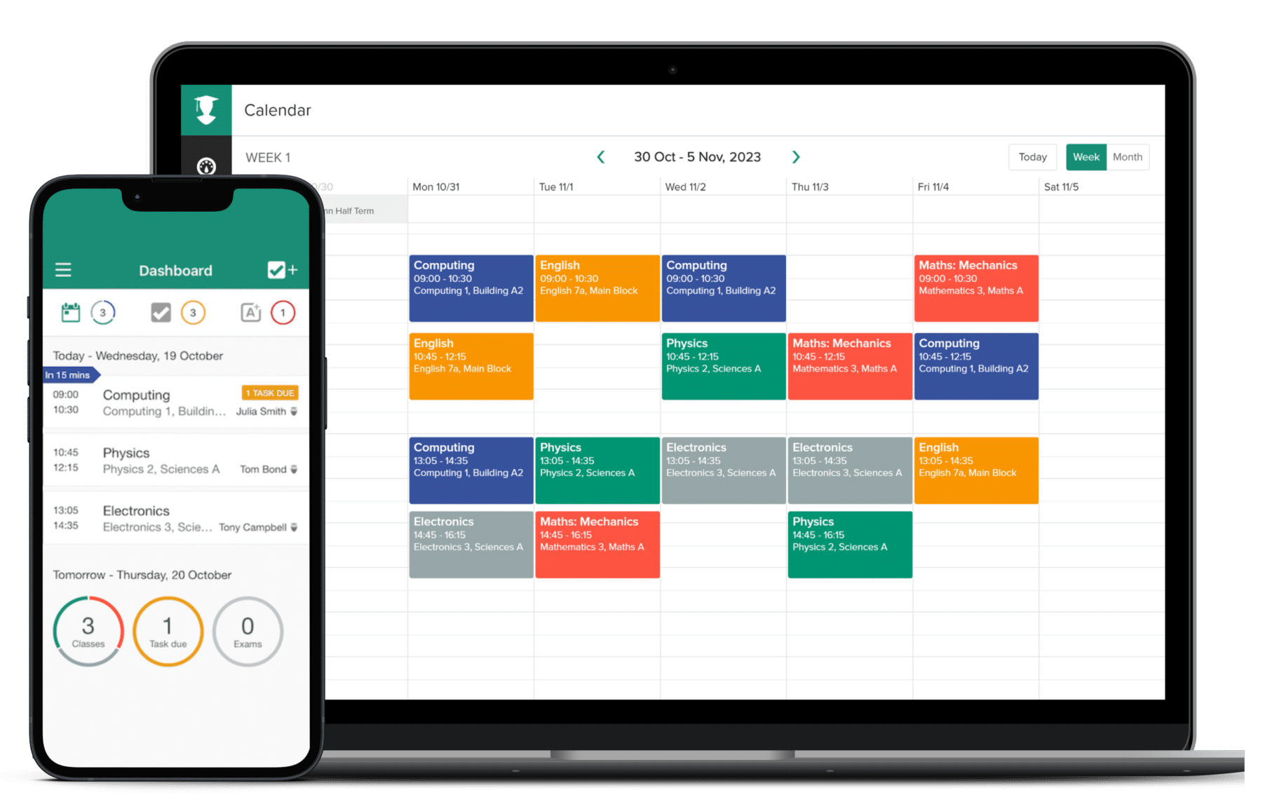

Figure 3.1: MyStudyLife Snapshot

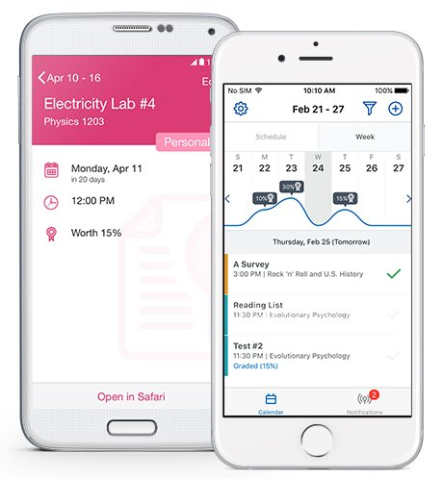
The second system in Figure 3.2 below is Brightspace Pulse which is a mobile application integrated with the Brightspace Learning Management System. Brightspace Pulse delivers notifications related to course activities, deadlines and learning resources which enables students to stay informed about their academic responsibilities. By compiling learning related information and providing timely alerts the system then supports learner awareness and engagement within digital learning environments. Its analytics driven notifications reflect the use of learner data to inform learning decisions which is aligning with learning analytics components relevant to this study.

Figure 3.2: Snapshot of Brightspace Pulse app
The final case study is Carnegie Learning’s Cognitive Tutor (MATHia) which is shown in Figure 3.3 below. It is an artificial intelligence based tutoring system designed to provide personalised support to learners. The system uses learner modelling methods to adjust content, feedback and problem difficulty. Carnegie Learning demonstrates how artificial intelligence can be applied to personalise learning support by aligning learning experiences to individual learners. Although focused on subject specific instruction, the system has the potential of AI-driven personalisation that informs the design of intelligent study support solutions.
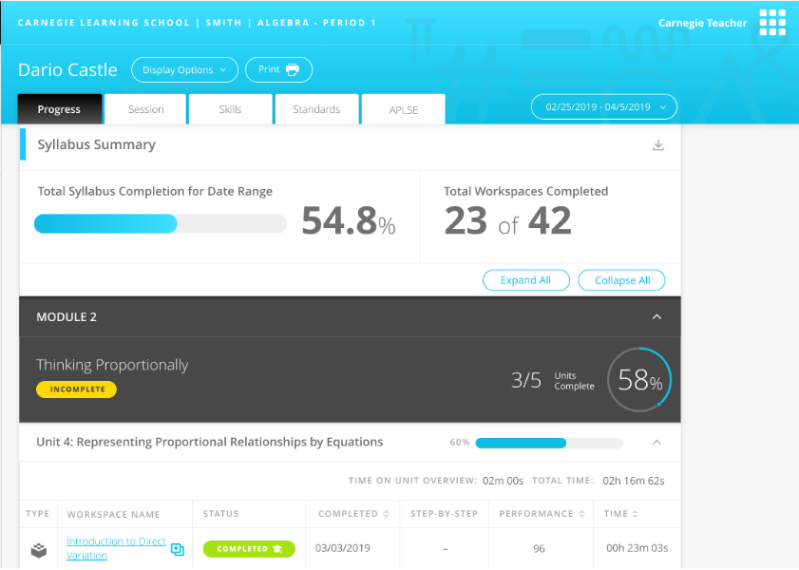

Figure 3.3: Carnegie Learning snapshot

Weaknesses in Existing Systems
The reviewed systems have intelligent features like automated reminders, adaptive content delivery using artificial intelligence based algorithms, digital timetable support and study planning to assist students with study organisation. These features are made to work independently and do not collectively support personalised time management through adaptive measures and intelligent learning recommendation prescriptions.

MyStudyLife offers simple scheduling and reminder capabilities but instead of depending on dynamic structures of timetables they require hand entry maintenance and manual scheduling. Although it aids in the organisation of studies, it does not add value to examining the academic performance, study behaviour and learning preferences of learners to help in the creation of learning schedules dynamically. The system also does not have any types of recommending suitable learning strategies or modifying study plans due to some changes in the working load, performance and time availability.

Brightspace Pulse provides deadline awareness and analytics driven notifications by being integrated with an institutional learning management system. Nonetheless, it is mainly concerned with information delivery as opposed to planning of the actual study or behavioural control.

Finally, the Cognitive Tutor by Carnegie Learning has high level of artificial intelligence due to its adaptive content delivery and personalised instructional feedback but personalisation is restricted to subject based learning exercises in predefined instruction settings. The system does not accommodate the larger academic planning requirements of workload in cross courses, time utilization or scheduling of individual studies. It also does not suggest the learning strategies in various courses or study backgrounds which limits its levels of application as an integrated study management system.

A common limitation in the 3 systems is the absence of an integration that combines learning analytics, artificial intelligence and self-regulated learning principles to support personalised study planning and recommendation.

Proposal of the New System
Current learning systems are mostly content delivery systems, just like the digital libraries or lecture halls, where students have access to learning materials but the systems do not actively manage the study activities of the students. The suggested system is intended to run as an intelligent study manager overlaying these platforms combining artificial intelligence, learning analytics and self-regulated learning philosophies to help manage adaptive study schedule planning and provide learning strategy advice. The system is able to coordinate and optimise study activities across courses by analysing learner behaviour and academic requirements as well as available study time which is an issue with the current systems where scheduling, analytics and smart support have been adopted on an individual basis. This holistic student based learning support system offers a student centred approach to the learning process that facilitates good study habits and academic success.

System Design
This section is the system design which will focus on how components of the proposed system and interactions are structured to support personalised study planning and learning method recommendation. Unified Modeling Language (UML) used to model the system through standard design diagrams.

Overview of UML as the Design Tool
Unified Modeling Language (UML) is used in this study to visually represent the structure and behaviour of the proposed intelligent study support system. UML diagrams provide a clear way to model system interactions, data components, and process flows involved in personalised study planning and learning strategy recommendation.

Use Case Diagram
Figure 3.4 illustrates the use case diagram of the proposed AI-powered personalised study planning and learning recommendation system. It shows the student as the primary actor interacting with the system to perform key functions such as registering and logging in, inputting academic details, specifying study time and preferences, planning study goals, generating and optimising personalised study timetables, receiving learning strategy recommendations, tracking study progress and performance, reviewing feedback, and receiving intelligent reminders and notifications. The diagram highlights how the system supports effective study planning and self-regulated learning through continuous and adaptive user interaction.

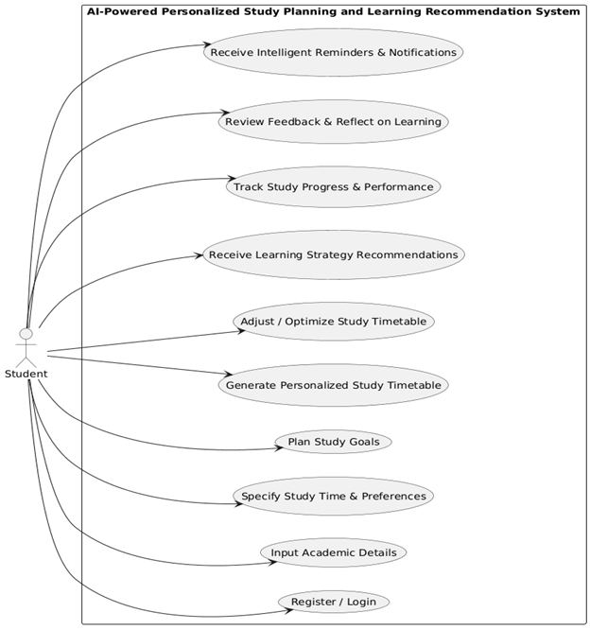

Figure 3.4: Use Case Diagram of the system

Class Diagram
Figure 3.5 presents the structural design of the proposed AI-powered personalised study planning and learning recommendation system. It illustrates the main classes, their attributes and the relationships between them. The Student class is to be the primary user and is associated with courses, a personalised study timetable and learning strategies. Components like the RecommendationEngine and ProgressTracker support the feature of adaptive timetable optimisation, learning strategy recommendation and performance monitoring while supporting classes like StudySession and Notification enable study activity tracking and reminder delivery.
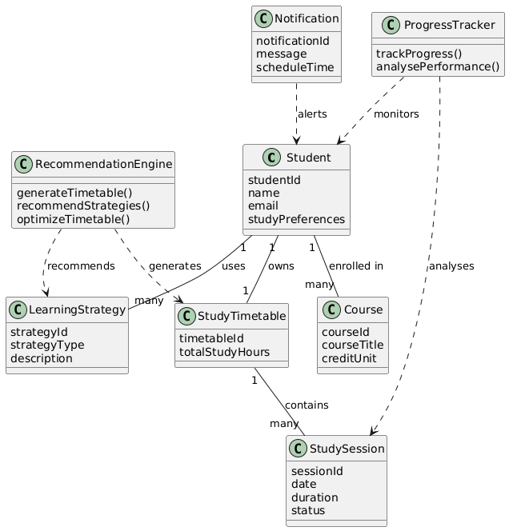

Figure 3.5: Class Diagram of the system

Sequence Diagram
The interaction between the student and the major system components like the user interface, the recommendation engine, study timetable module, progress tracker and the notification module are represented in Figure 3.6. The diagram shows the way the data related to learners is gathered, processed to create and optimize a personalized study schedule, and assisted by the progress tracking as well as the smart notifications, which reflect the adaptive and feedback based nature of the system.

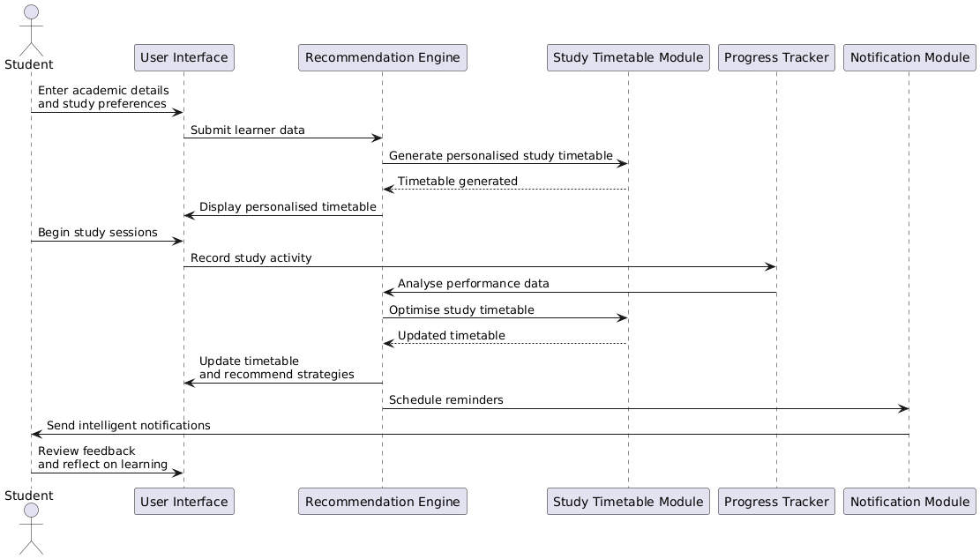

Figure 3.6: Sequence Diagram of the system

Activity Diagram
The two figures below demonstrate the activity diagrams of the proposed AI powered personalised study planning and learning recommendation system. The personalised study planning workflow is illustrated in Figure 3.7a which illustrates the way that student data is gathered and processed to create a custom learning schedule and prescribe the best learning strategies. Figure 3.7b shows the study monitoring and optimisation workflow where the data on the study activity and performance are monitored and analysed to decide whether some adjustments have to be made thus allowing the timetable to be optimised, the strategy to be updated, intelligent reminders and reflective learning support.

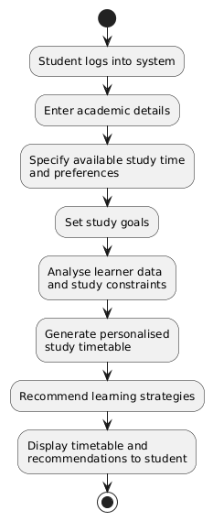
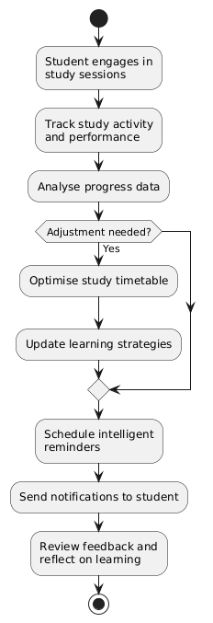

Figure 3.7a : Activity Diagram for Personalised Figure 3.7b: Activity Diagram for
Study Planning Workflow Study Monitoring &
Optimisation Workflow

Technological Stack
This section presents the technological stack for the development of the proposed system. It provides an overview of the technologies selected for the frontend, backend, database and additional tools.

Overview of Selected Technologies
The proposed system will take a mobile based, client-server architecture model that is aimed at providing personalised study planning and learning recommendation to the students. The mobile-first frontend interface allows students to use the system on a handheld device whereas a robust backend service can process and make informed decisions and integrate the system. The intelligence of the system is a combination of rule based reasoning with simple machine learning methods used to assist the adaptive management of the study timetable and recommending the learning strategies. Relational database management system is employed to uphold dependable storage of user information, educational records and learning analytics, as well as the support tools that contribute to the security and maintainability. Beyond the selected frontend, backend and database technologies, the proposed system also follows a structured artificial intelligence methodology to ensure that its intelligent functions are implemented in a measurable way. This methodology defines the workflow for learner data collection, training dataset preparation, feature engineering, model training, model testing and deployment for recommendation and timetable optimisation.

Frontend Technologies
- Next.js (React Framework): A React based framework employed to create the mobile-based user interface and mobile-first interface which is able to be responsive with an efficient interaction with backend services.
Features:
- Responsive Design: Enables the application to adapt to different mobile screen sizes and orientations.

- Component Based Architecture: Provides reusable user interface components.

- Client-Server Interaction: Communicates with the backend through APIs.

Backend Technologies
- Django (Python Web Framework): A Python framework used to implement the backend logic of the system.
- Django REST Framework (DRF): Used to expose backend functionalities as RESTful APIs.
- Rule-Based Recommendation Engine with scikit-learn (Python): A backend recommendation module implemented in Python that combines a rule based logic with basic machine learning techniques using the scikit-learn.
Features:
- Rule-Based Decision Logic: Applies rules and heuristics to allocate study time and recommend appropriate learning strategies.

- API Management: Supports data exchange between the frontend and backend through RESTful services.

- Adaptive Intelligence: Enables the system to analyse learner behaviour and performance data.

- Machine Learning Support: Utilises basic machine learning models provided by scikit-learn to identify patterns in study behaviour.

Database and Additional Tools
- PostgreSQL (Relational Database Management System): PostgreSQL is used as the primary database for the system to store student data.
- Authentication and Security (JWT with Django REST Framework): JSON Web Tokens (JWT) are used to implement secure authentication within the system. JWT based authentication ensures that only authorised users can access system functionalities.
- Version Control (Git and GitHub): Git is used for source code version control, while GitHub supports code management and project tracking.

AI Methodology and Model Development Process
This section presents the methodology for implementing the artificial intelligence component of the proposed AI-powered personalised study planning and learning recommendation system. The methodology explains how data is obtained from learner interaction, how prediction models are developed and evaluated, and how model outputs are integrated into the application to support adaptive decision-making.

AI Objectives and Prediction Tasks
The AI component of this study is designed to support two major tasks in line with the project objectives:
- Adherence prediction: The system estimates the likelihood that a student will follow through with planned study sessions.
- Learning strategy recommendation: The system suggests suitable strategy categories based on learner profile and study behaviour signals.
These two tasks support personalised timetable optimisation and targeted learning support.

Data Collection Strategy
The proposed system adopts an interaction-based data collection approach where relevant learner data is captured during normal use of the platform. The collected data includes profile variables such as preferred learning style and available study time, planning variables such as planned study duration and course difficulty, and monitoring variables such as actual study duration, completion rate and self-reported focus score. Short term performance indicators are also captured to improve recommendation quality.

Dataset Construction and Target Definition
A supervised learning dataset is constructed from recorded study activities. Each row represents a study session instance with input features and associated target values. Typical input features include planned minutes, actual minutes, completion rate, focus score, course difficulty, session frequency in recent days and deadline pressure indicators. Two target outputs are defined for modelling. The first target is adherence score which is represented as a continuous value between 0 and 1. The second target is strategy label, represented as a categorical class for recommended learning approach.

Data Preprocessing and Feature Engineering
Before model training, the dataset is prepared through preprocessing operations to ensure quality and consistency. Missing numerical values are handled with median imputation while categorical values are handled with mode imputation. Categorical variables are transformed into machine readable encoding, and behavioural trend features are derived from historical activity records. Dataset splitting is carried out in a time-aware and user-aware manner to reduce leakage and produce more realistic testing outcomes.

Model Selection and Training Procedure
The study adopts a two-stage intelligence strategy. First, a rule-based baseline is implemented to provide stable and explainable initial recommendations. Second, machine learning models are trained to improve adaptivity and predictive performance. For adherence prediction, tree-based regression models such as Random Forest or Gradient Boosting are used. For strategy recommendation, tree-based classification models are used. Training is performed using a train-validation-test workflow with cross-validation and hyperparameter tuning before final model selection.

Model Testing and Evaluation Metrics
Model evaluation is performed using task-specific metrics. For adherence prediction, the metrics used are Mean Absolute Error (MAE), Root Mean Squared Error (RMSE) and R-squared (R2). For strategy recommendation, the metrics used are Accuracy, Precision, Recall and F1-score, supported by confusion matrix analysis. To validate the intelligence contribution of the system, machine learning outputs are compared against baseline rule based outputs.

Deployment, Monitoring and Retraining
After evaluation, selected models are exported as versioned model artifacts and integrated into backend inference services. During system operation, prediction logs and usage outcomes are monitored to detect performance degradation or behavioural drift. A rule based fallback mechanism is retained to maintain reliability where model inference is unavailable. Model retraining is carried out periodically or triggered when defined performance thresholds are not met.

Ethical and Reliability Considerations
The AI methodology of the proposed system follows key ethical and reliability requirements. User consent is required for data usage in analytics and model training. Training datasets are handled with privacy-aware procedures and minimum exposure of personally identifying information. Recommendation outputs are designed to be understandable and adjustable by users, thereby maintaining learner autonomy while supporting trust and responsible AI use in educational settings.

References
Borchers, C., Fleischer, H., Yaron, D. J., McLaren, B. M., Scheiter, K., Aleven, V., & Schanze, S. (2025). Problem-Solving Strategies in Stoichiometry Across Two Intelligent Tutoring Systems: A Cross-National Study. Journal of Science Education and Technology, 34(2), 384-400.
Boroowa, A., & Herodotou, C. (2022). Learning analytics in open and distance higher education: The case of the Open University UK. In Learning analytics in open and distributed learning: Potential and challenges (pp. 47-62). Singapore: Springer Nature Singapore.

Broadbent, J., & Poon, W. L. (2015). Self-regulated learning strategies and academic achievement in online higher education learning environments: A systematic review. The Internet and Higher Education, 27, 1–13.

Broadbent, J. (2017). Comparing online and blended learners’ self-regulated learning strategies and academic performance. The Internet and Higher Education, 33, 24–32.

Chu, H. C., Hwang, G. H., Tu, Y. F., & Yang, K. H. (2022). Roles and research trends of artificial intelligence in higher education: A systematic review of the top 50 most-cited articles. Australasian Journal of Educational Technology, 38(3), 22-42.

Drachsler, H., & Greller, W. (2016, April). Privacy and analytics: it's a DELICATE issue a checklist for trusted learning analytics. In Proceedings of the sixth international conference on learning analytics & knowledge (pp. 89-98).
Hattie, L. D., Sahlberg, C. W., & Comer, P. P. (2023). Impact of mobile learning apps on study habits and academic performance of college students in the United States: A review of literature. Journal of Education, 6(3), 13-22.

Herodotou, C., Carr, J., Shrestha, S., Comfort, C., Bayer, V., Maguire, C., ... & Fernandez, M. (2025, March). Prescriptive analytics motivating distance learning students to take remedial action: A case study of a student-facing dashboard. In Proceedings of the 15th International Learning Analytics and Knowledge Conference (pp. 306-316).

Hlosta, M., Herodotou, C., Papathoma, T., Gillespie, A., & Bergamin, P. (2022). Predictive learning analytics in online education: A deeper understanding through explaining algorithmic errors. Computers and Education: Artificial Intelligence, 3, 100108.

Huang, J., Cai, Y., Lv, Z., Huang, Y., & Zheng, X. L. (2024). Toward self-regulated learning: effects of different types of data-driven feedback on pupils’ mathematics word problem-solving performance. Frontiers in Psychology, 15, 1356852.

Ifenthaler, D., & Yau, J. Y. K. (2020). Utilising learning analytics to support study success in higher education: a systematic review. Educational Technology Research and Development, 68(4), 1961-1990.

Jansen, R. S., Van Leeuwen, A., Janssen, J., Jak, S., & Kester, L. (2019). Self-regulated learning partially mediates the effect of self-regulated learning interventions on achievement in higher education: A meta-analysis. Educational Research Review, 28, 100292.

Kim, J., Merrill, K., Xu, K., & Sellnow, D. D. (2020). My teacher is a machine: Understanding students’ perceptions of AI teaching assistants in online education. International Journal of Human–Computer Interaction, 36(20), 1902-1911.

Lai, C. H., Jong, B. S., Hsia, Y. T., & Lin, T. W. (2020). Using reminder tools to increase learning motivation: A comparison of mobile devices, email and e-learning platforms.

Lim, L. A., Gentili, S., Pardo, A., Kovanović, V., Whitelock-Wainwright, A., Gašević, D., & Dawson, S. (2021). What changes, and for whom? A study of the impact of learning analytics-based process feedback in a large course. Learning and Instruction, 72, 101202.

Luckin, R., & Holmes, W. (2016). Intelligence unleashed: An argument for AI in education.

Matcha, W., Gašević, D., Uzir, N. A. A., Jovanović, J., & Pardo, A. (2019, March). Analytics of learning strategies: Associations with academic performance and feedback. In Proceedings of the 9th international conference on learning analytics & knowledge (pp. 461-470).

Miao, F., & Holmes, W. (2021). Artificial intelligence and education: Guidance for policy-makers.

Molenaar, I., de Mooij, S., Azevedo, R., Bannert, M., Järvelä, S., & Gašević, D. (2023). Measuring self-regulated learning and the role of AI: Five years of research using multimodal multichannel data. Computers in Human Behavior, 139, 107540.

Nagashima, T., Tseng, S., Ling, E., Bartel, A. N., Vest, N. A., Silla, E. M., ... & Aleven, V. (2022, June). Students’ self-regulated use of diagrams in a choice-based Intelligent Tutoring System. In Proceedings of the 16th International Conference of the Learning Sciences, ICLS 2022.

Nobbe, L., Breitwieser, J., Biedermann, D., & Brod, G. (2024). Smartphone-based study reminders can be a double-edged sword. npj Science of Learning, 9(1), 40.

Oulasvirta, A., Rattenbury, T., Ma, L., & Raita, E. (2012). Habits make smartphone use more pervasive. Personal and Ubiquitous Computing, 16(1), 105–114.

Ouyang, Z. (2025). Self-regulated learning and engagement as serial mediators between AI-driven adaptive learning platform characteristics and educational quality: a psychological mechanism analysis. Frontiers in Psychology, 16, 1646469.

Panadero, E. (2017). A review of self-regulated learning: Six models and four directions for research. Frontiers in Psychology, 8, 422.

Schraw, G., Crippen, K. J., & Hartley, K. (2006). Promoting self-regulation in science education: Metacognition as part of a broader perspective on learning. Research in Science Education, 36(1–2), 111–139.

Sedrakyan, G., Malmberg, J., Verbert, K., Järvelä, S., & Kirschner, P. A. (2020). Linking learning behavior analytics and learning science concepts: Designing a learning analytics dashboard for feedback to support learning regulation. Computers in Human Behavior, 107, 105512.

Sousa, E. B. D., Alexandre, B., Ferreira Mello, R., Pontual Falcão, T., Vesin, B., & Gašević, D. (2021). Applications of learning analytics in high schools: A systematic literature review. Frontiers in Artificial Intelligence, 4, 737891.

Stinar, F., Lee, H., Belitz, C., Nasiar, N., Fancsali, S. E., Ritter, S., ... & Bosch, N. (2025). Fairness of Bayesian Knowledge Tracing for Math Learners of Different Reading Ability. International Educational Data Mining Society.

Tang, K. H. D. (2024). Implications of artificial intelligence for teaching and learning. Acta Pedagogia Asiana, 3(2), 65-79.

Viberg, O., Hatakka, M., Bälter, O., & Mavroudi, A. (2018). The current landscape of learning analytics in higher education. Computers in Human Behavior, 89, 98-110.

Wu, X. Y., Ng, D. T. K., & Chiu, T. K. (2026). Self-Regulated Learning with AI: A Comparative Analysis of General-Purpose and Task-Specific Platforms. International Journal of Technology in Education, 9(1), 279-302.

Zimmerman, B. J., & Schunk, D. H. (2011). Self-regulated learning and performance: An introduction and an overview. Handbook of self-regulation of learning and performance, 15-26.

Zimmerman, B. J. (2002). Becoming a self-regulated learner: An overview. Theory Into Practice, 41(2), 64–70.

